
Table of Contents
Group and System Details 5
1. Executive Summary 6
2. Introduction 6
2.1 Background 6
2.2 Problem Statement 6
2.3 Objectives 6
2.4 Scope 7
3. Stakeholder Analysis 7
4. Feasibility Analysis 7
5. Functional Requirements 8
6. Non-Functional Requirements 9
7. Use Case Analysis 9
UC-01: Login 9
UC-02: Manage Customers 10
UC-03: Process Orders (POS) 10
UC-04: Manage Deliveries 10
UC-05: Manage Inventory / Menu 11
UC-06: Manage Suppliers 11
UC-07: Process Purchase Orders 12
UC-08: Manage Employees / Staff 12
UC-09: Generate Reports 12
UC-10: View Analytics Dashboard 13
8. System Architecture 13
9. Database Design 14
10. User Interface Design 14
10.1 Login Screen (Form1.cs) 14
10.2 Cashier Dashboard (Cashier.cs) 14
10.3 Point of Sale Tab 15
10.4 Customer Management Tab 15
10.5 Today's Orders Tab 15
10.6 Head Chef Dashboard (HeadChef.cs) 15
10.7 Manager Dashboard (Manager.cs) 15
10.8 Owner Dashboard (OwnerDashboard.cs) 15
16
11. Security Design 19
12. System Testing 19
13. Implemented User Stories / Functionality Listing 21
14. System Benefits 23
15. Future Enhancements 23
16. Conclusion 24

Group and System Details
Group No. | System Name
Westville Group 26 | Cafe101 Order & Delivery Management System

Estimated Individual Contribution
No. | Student Number | Name & Surname | Estimated Contribution to M2 | Signature
1 | 223012780 | Mpiwa Myeni | 16.67% | M. Myeni
2 | 223109140 | Asanda Jele | 16.67% | A. Jele
3 | 223031988 | Siyanda Thango | 16.67% | S. Thango
4 | 223034963 | Bongumusa Gumede | 16.67% | B. Gumede
5 | 223145384 | Lungisani Mnyandu | 16.67% | L. Mnyandu
6 | 223151269 | Alutha Mabona | 16.67% | A. Mabona

Group Name: Code Crafters

Slogan: "Where Technology Meets Taste — Smarter Ordering, Faster Service."

1. Executive Summary
Café 101 is a desktop system built by Code Crafters for the ISTN3AS module at the University of KwaZulu-Natal. The system was created to manage all day-to-day operations of a café, such as taking orders, tracking deliveries, and generating sales reports. It replaces the old way of writing orders on paper with a proper software solution that is faster and less likely to make mistakes.
The system was built using C# with Windows Forms and uses a Microsoft SQL Server database to store all data. It has four different user roles — Cashier, Head Chef, Manager, and Owner — and each role only sees the part of the system that is relevant to their job. The main features include: a login system with role-based access; a Point-of-Sale (POS) screen for placing orders; a kitchen display for the chef; tools for managing stock, suppliers, and staff; and a reporting dashboard for the owner.

2. Introduction

2.1 Background
Many cafés and small restaurants still rely on manual, paper-based processes to take orders and communicate with the kitchen. This causes problems like wrong orders being made, stock running out without warning, and no easy way to see how the business is performing. Café 101 was built to solve these problems by providing a simple digital system that connects the cashier, the kitchen, and the manager all in one place.

2.2 Problem Statement
Small café businesses face the following common problems that this system was designed to fix:
- Orders written on paper often get lost or are difficult to read, leading to mistakes.
- There is no easy way to check how much stock is left, so the café often runs out of popular items.
- Staff have no clear boundary between their responsibilities, which causes confusion.
- The owner has no way to quickly view how the business is performing without going through lots of paperwork.

2.3 Objectives
- Build a secure login that makes sure each staff member only has access to their own part of the system.
- Create a Point-of-Sale screen where the cashier can take customer orders quickly and accurately.
- Build a kitchen display screen so the Head Chef can always see which orders need to be prepared.
- Give the manager the tools to manage stock, suppliers, purchase orders, and staff.
- Provide the owner with a dashboard that shows sales figures and business reports for any date range.
- Make sure all data is stored safely in a properly structured database.

2.4 Scope
The system handles everything from when a customer places an order to when it is delivered or served. It covers the cashier, kitchen, and management sides of the business for one café branch. The system does not include online ordering through a website, a mobile app, or connecting to a payment machine — these are listed as future improvements.

3. Stakeholder Analysis
A stakeholder is anyone who has an interest in the system or is affected by how it works. The table below lists the main stakeholders for Café 101.

Stakeholder | Role | What They Need | Influence
Customer | End beneficiary | Fast and correct order processing; reliable delivery | Low
Cashier | Primary operator | A simple POS screen to take orders and print receipts quickly | High
Head Chef | Kitchen operations | A live screen showing which orders to prepare and their status | High
Manager | Operational oversight | Tools to manage staff, stock levels, suppliers, and purchase orders | High
Owner | Business owner | A dashboard showing sales figures, reports, and business analytics | High
Supplier | External goods provider | Accurate purchase orders so they know what to deliver and when | Medium

4. Feasibility Analysis
Before starting development, the team checked whether the project was realistic from four different angles.

Feasibility Type | Assessment
Technical | We used C#, Windows Forms, and Microsoft SQL Server — technologies that were taught during the course and are well-supported. Visual Studio 2022 and SQL Server Management Studio (SSMS) are both free for students, so no extra software needed to be purchased.
Operational | Each role in the system has its own simple screen that only shows what that person needs. We estimate it would take less than two hours to train a new staff member. The system runs on a normal desktop computer, which most businesses already have.
Economic | Since this is a student project, the development cost was just time and effort. If used in a real business, the system would save money by replacing expensive monthly POS subscriptions with a one-off custom solution. The business recover the cost within about six months.
Schedule | The project was completed within the academic semester. The work was split into three phases: planning and design (weeks 1–3), building the system (weeks 4–9), and testing and documentation (weeks 10–13). All deadlines were met.

5. Functional Requirements
Functional requirements describe what the system must be able to do. Each requirement below has been given a unique ID and a priority level (Critical = must have, High = very important, Medium = nice to have).

Req. ID | Module | What the System Must Do | Priority
FR-01 | Authentication | The system must check a user's username and password and give them access based on their role. | Critical
FR-02 | Authentication | The system must lock a user's account after three wrong password attempts in a row. | High
FR-03 | Customer Management | The cashier must be able to add, edit, search for, and delete customer records. | Critical
FR-04 | POS / Orders | The cashier must be able to create an order, add menu items, apply a discount, and complete the sale. | Critical
FR-05 | POS / Orders | The system must automatically work out the total cost of an order, including tax. | Critical
FR-06 | POS / Orders | The system must print a receipt when an order is completed. | Critical
FR-07 | Delivery | The cashier must be able to enter a delivery address (city and suburb) when the order type is Delivery. | High
FR-08 | Kitchen | The system must show all new orders to the Head Chef in real time. | Critical
FR-09 | Kitchen | The Head Chef must be able to change an order's status to Preparing, Ready, or Served. | Critical
FR-10 | Inventory | The manager must be able to add, update, and delete menu and stock items. | Critical
FR-11 | Inventory | The system must warn the manager when a stock item drops below the minimum level. | High
FR-12 | Supplier Management | The manager must be able to keep a list of suppliers with their contact details. | High
FR-13 | Purchase Orders | The manager must be able to create a purchase order that is linked to a supplier. | High
FR-14 | Employees | The manager must be able to add, edit, and remove employee records. | Medium
FR-15 | Reporting | The owner must be able to generate and print sales and delivery reports filtered by date. | High
FR-16 | Analytics | The owner dashboard must show key business figures like daily revenue, order count, and top-selling items. | High

6. Non-Functional Requirements
Non-functional requirements describe how well the system must perform, not just what it must do. These include things like security, speed, and reliability.

Category | Requirement
Security | Passwords must be stored as hashed values (one-way encryption) so that even if the database is accessed, no plain-text passwords can be read. Each user can only access their own role screens. The system uses parameterized database queries to prevent SQL injection attacks. Error messages shown to users must never display technical details about the system.
Performance | Any dashboard or screen must be loaded within three seconds when up to 20 users are using the system at the same time. Database searches are made faster by using indexes in the most searched fields (such as OrderID, CustomerID, and EmployeeID).
Reliability | When the system saves data that involves more than one step (for example, placing an order and updating stock at the same time), it uses database transactions to make sure either everything is saved, or nothing is — there is no risk of incomplete data being stored.
Scalability | Because the system separates the screens (what you see), the business rules (how it works), and the database (where data is stored) into three separate layers, it is easy to add more computers running the system without needing to rewrite any code.
Usability | All the screens in the system look and feel the same, using the same colors, fonts, and layout. A user should be able to complete any main task in no more than two clicks from their home screen. The system also checks that all forms are correctly filled in before allowing the user to continue.

7. Use Case Analysis
A use case describes a specific task that a user can perform in the system. Each case below includes who does the task, what steps are followed, and what happens at the end.

UC-01: Login
Field | Detail
Actor | All Users
Description | This use case allows any staff member to log into the system using their username and password and be taken to the correct screen based on their role.
Preconditions | The application is open and the login screen is showing.
Main Flow | 1. The user types in their username and password. 2. The system checks if the details are correct. 3. The system identifies the user's role. 4. The system opens the correct dashboard for that role.
Alternative Flow | If the details are wrong, an error message appears and the system counts the failed attempt. After three failed attempts, the account is locked.
Postconditions | The user is logged in, and their role dashboard is displayed.

UC-02: Manage Customers
Field | Detail
Actor | Cashier
Description | This allows the cashier to add new customers, update their details, search for a customer, or remove a customer from the system.
Preconditions | The cashier is logged in.
Main Flow | 1. The cashier opens the Customers tab. 2. They click Add, Edit, or Delete. 3. The system checks that all required fields are filled in. 4. The changes are saved to the database.
Alternative Flow | If the cashier tries to delete a customer who has active orders, the system blocks the deletion and shows a warning. If a duplicate contact is detected, the system warns the cashier before saving.
Postconditions | The customer record is saved or updated, and the list on screen is refreshed.

UC-03: Process Orders (POS)
Field | Detail
Actor | Cashier
Description | This is the main ordering process. The cashier uses this to build a customer's order, work out the total cost, and complete the sale.
Preconditions | The cashier is logged in, and menu items are loaded in the system.
Main Flow | 1. The cashier selects items from the menu and adds them to the cart. 2. The system automatically calculates the subtotal, tax, discount, and grand total. 3. The cashier selects the order type (Dine-In, Takeaway, or Delivery) and the payment method. 4. The cashier clicks Place Order. 5. The system saves the order and prints a receipt.
Alternative Flow | If the cashier clicks Clear Order, the cart is emptied and no record is saved to the database.
Postconditions | The order is saved with a status of Received, the receipt is printed, and the kitchen queue is updated.

UC-04: Manage Deliveries
Field | Detail
Actor | Cashier
Description | This case allows the cashier to record a delivery address when a customer's order needs to be delivered.
Preconditions | The order type has been set to Delivery.
Main Flow | 1. When Delivery is selected, address fields (city and suburb) appear on screen. 2. The cashier fills in the address. 3. The address is saved together with the order.
Alternative Flow | If the cashier tries to place the order without filling in the address, the system blocks the action and shows an error message.
Postconditions | The delivery address is recorded and linked to the order.

UC-05: Manage Inventory / Menu
Field | Detail
Actor | Manager
Description | This use case allows the manager to keep the menu and stock list up to date by adding new items, editing existing ones, or removing items that are no longer available.
Preconditions | The manager is logged in.
Main Flow | 1. The manager opens the Menu/Inventory section. 2. They click Add, Edit, or Delete for the relevant item. 3. The system checks that the stock quantity and minimum threshold have been filled in correctly. 4. The system saves the record.
Alternative Flow | If the stock quantity for an item drops below the minimum threshold, the item is highlighted in red, and a low-stock warning is shown.
Postconditions | The inventory record is updated, and any low-stock alerts are displayed.

UC-06: Manage Suppliers
Field | Detail
Actor | Manager
Description | This case allows the manager to keep a list of the café's suppliers, including their contact information, so that purchase orders can be sent to them.
Preconditions | The manager is logged in.
Main Flow | 1. The manager opens the Suppliers section. 2. They add a new supplier or edit or delete an existing one. 3. The system checks that all contact fields are filled in. 4. The record is saved to the database.
Alternative Flow | If the manager tries to delete a supplier who is linked to an open purchase order, the system asks for confirmation before allowing the deletion.
Postconditions | The supplier register is updated.

UC-07: Process Purchase Orders
Field | Detail
Actor | Manager
Description | This case allows the manager to create a purchase order to request stock from a supplier, and to update the order when the stock arrives.
Preconditions | At least one supplier and one inventory item must already exist in the system.
Main Flow | 1. The manager selects a supplier. 2. They add the items they want to order, with the quantity and unit price. 3. The system calculates the total cost. 4. The manager submits the order (status: Pending). 5. When the stock arrives, the manager updates the status to Received.
Alternative Flow | If the order is no longer needed, the manager can cancel it and the status is updated to Cancelled.
Postconditions | The purchase order is saved, and the inventory is updated when the order is marked as Received.

UC-08: Manage Employees / Staff
Field | Detail
Actor | Manager
Description | This use case allows the manager to register new staff members, update their details, and remove staff who no longer work at the café.
Preconditions | The manager is logged in.
Main Flow | 1. The manager opens the Staff section. 2. They click Add New Employee and fill in the registration form. 3. A role is assigned to the new employee. 4. The system saves the record and creates a system login account for the employee.
Alternative Flow | If the same employee details already exist in the system, the manager is warned before the record is saved.
Postconditions | The employee record has been created, and the new staff member can now log into the system.

UC-09: Generate Reports
Field | Detail
Actor | Owner
Description | This case allows the owner to generate business reports for a chosen date range, such as sales totals, product performance, and customer activity.
Preconditions | The owner is logged in and there is transaction data in the system.
Main Flow | 1. The owner selects a start and end date. 2. They choose the type of report (Sales, Products, or Customers). 3. The system fetches the relevant data and displays the report. 4. The owner can print the report if needed.
Alternative Flow | If there is no data for the selected date range, the system shows a message saying, 'No records found'.
Postconditions | The report is shown on screen and can be printed.

UC-10: View Analytics Dashboard
Field | Detail
Actor | Owner
Description | This case allows the owner to view a summary of the business's key performance indicators (KPIs) for any date range, including a sales chart and top-selling products.
Preconditions | The owner is logged in and there is enough transaction data in the system.
Main Flow | 1. The owner selects a date range using the From and To date pickers. 2. The system calculates the KPIs: total revenue, number of orders, and average order value. 3. The sales chart is updated with the data for that period. 4. The top 5 and least 5 selling products are shown in their grids.
Alternative Flow | If there is no data for the selected period, all KPI tiles show zero and the chart is empty.
Postconditions | The KPI tiles, chart, and product grids are all updated for the selected date range.

8. System Architecture
The Café 101 system is built using three-tier architecture, which means the system is divided into three separate layers that each have their own job. This is a common design pattern used in professional software development because it makes the system easier to maintain and update.

Tier | Technology Used | What It Does
Presentation (Layer 1) | C# Windows Forms (.NET 4.8); GDI+ for drawing the interface | This is what the user sees on the screen. It includes all the forms, buttons, and menus for each role. The animated splash screen is also built here using GDI+.
Business Logic (Layer 2) | C# form code; DatabaseHelper static class | This layer contains all the rules that make the system work — for example, how to calculate the total price of an order, how to check if stock is below the minimum level, and how to route each user to their correct screen after login.
Data Access (Layer 3) | Microsoft. Data. SQL Client; Parameterised SQL queries | This layer is responsible for reading and writing data to the database. All database queries use parameters instead of joining strings together, which protects the system from SQL injection attacks.
Database | Microsoft SQL Server 2019+ (hosted on a remote server) | This is where all the data is permanently stored, including users, customers, orders, stock items, suppliers, and employees. The database is designed using a normalised structure to avoid duplicate data.

9. Database Design
The database stores all the information used by the Café 101 system. It is hosted on Microsoft SQL Server and is designed using a normalised structure, which means information is not repeated unnecessarily across different tables. The table below gives an overview of all the main tables, their primary keys, and how they are connected to each other.

Table | Primary Key | Main Columns | Linked To
Users | UserID | FirstName, LastName, Email, PasswordHash, Role | Referenced by Orders (as CashierID)
Customers | CustomerID | FirstName, LastName, Email, Phone, Address | Referenced by Orders
Categories | CategoryID | CategoryName | Referenced by MenuItems
MenuItems | ItemID | CategoryID, ItemName, Description, Price, Stock, MinStock | Links to Categories; referenced by OrderItems
Orders | OrderID | CustomerID, CashierID, OrderType, Status, TotalAmount, PaymentMethod | Links to Customers and Users; referenced by OrderItems
OrderItems | OrderItemID | OrderID, ItemID, ItemName, Qty, UnitPrice (Selling Price), LineTotal | Links to Orders and MenuItems
Suppliers | SupplierID | CompanyName, ContactName, Phone, Email, Address | Referenced by PurchaseOrders
PurchaseOrders | POID | SupplierID, ItemName, Qty, UnitPrice (Cost Price), TotalCost, Status | Links to Suppliers

10. User Interface Design
All the screens in the system use the same colour scheme — dark brown (4A2C0A), gold (#C8960C), and cream (F0EDE8) to give the system a consistent, professional look. The screens were built entirely using GDI+ and WinForms, without any third-party design libraries.

10.1 Login Screen (Form1.cs)
The login screen is split into two panels. The left panel shows the animated Café 101 logo and the name of the application. The right panel has email and password fields with a Login button. If the user enters the wrong details, an error message appears below the fields. After three wrong attempts, the account is locked and a lockout message is shown.

10.2 Cashier Dashboard (Cashier.cs)
When the cashier logs in, they see a home screen with three large tiles: Place Order, Customers, and Today's Orders. The main working area uses tabs to switch between these three sections. A navigation bar at the top shows the logged-in user's name and a badge showing how many orders have been placed today.

10.3 Point of Sale Tab
This is where the cashier takes customer orders. The left side shows the menu, organised by category. The cashier clicks on an item to add it to the cart on the right side, where the subtotal, tax, discount, and grand total are automatically updated. At the bottom, the cashier selects the order type and payment method, then clicks Place Order to complete the sale and print the receipt.

10.4 Customer Management Tab
This tab shows a table of all customers. The cashier can use the search bar to quickly find a customer by typing two or more characters. Buttons at the top allow the cashier to add a new customer, edit an existing one, or delete a customer. A pop-up form is used for adding or editing customer details.

10.5 Today's Orders Tab
This tab shows all the orders that have been placed during the current working day. Each row shows the order number, customer name, order type, status, and total amount. The manager can also use this tab to update the status of any order.

10.6 Head Chef Dashboard (HeadChef.cs)
The Head Chef's screen is divided into two sides. The left side shows a live list of all active orders, with different colours showing the status of each order (orange = Received, blue = Preparing, green = Ready). When the chef clicks on an order, the right side shows the full list of items in that order. Three buttons at the top allow the chef to update the order status: START PREPARING, MARK AS READY, and MARK AS SERVED. The screen automatically refreshes to show new orders as they come in.

10.7 Manager Dashboard (Manager.cs)
The manager's screen has a sidebar menu on the left with links to different sections: Overview, Orders, Menu/Inventory, Suppliers, Staff, and Reports. At the top, there are summary cards showing the day's, week's, and month's revenue and order counts. Each section opens a data table where the manager can add, edit, or delete records. The Reports section allows the manager to print a Daily, Weekly, or Monthly sales report.

10.8 Owner Dashboard (OwnerDashboard.cs)
The owner's screen is a scrollable analytics page. At the top, the owner can select a date range using two date pickers (From and to). The screen then shows KPI tiles (total revenue, number of orders, average order value, and payment method breakdown), a sales chart that displays daily data as a line and area graph, a table of the top 5 best-selling items, a table of the 5 least-selling items, and a customer analytics section showing new versus returning customers. The owner can also print reports from this screen.

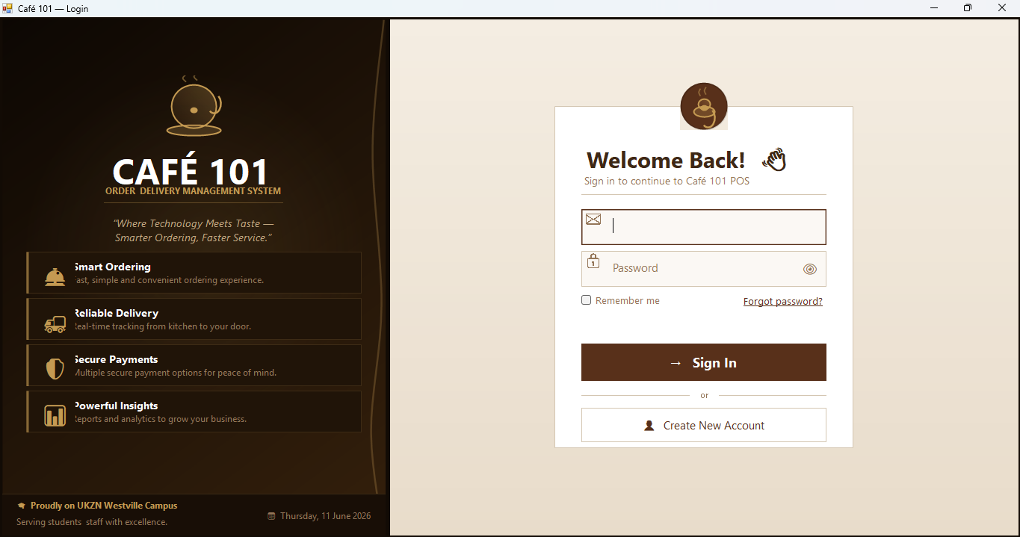
Figure 1: Login Screen
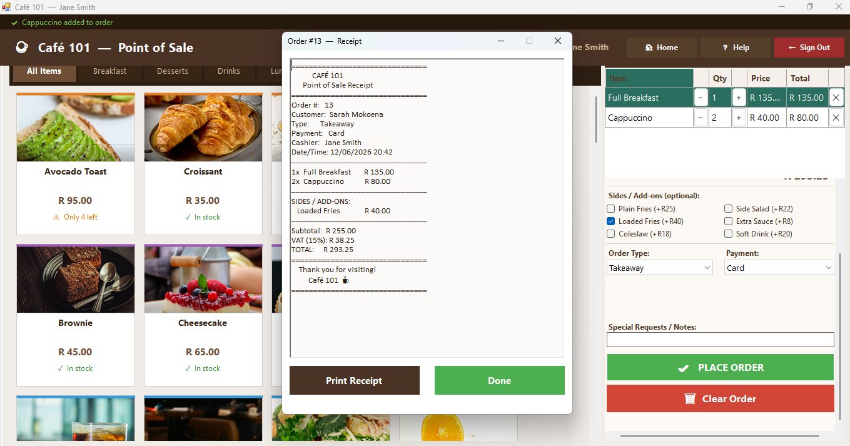
Figure 2: Receipt generation

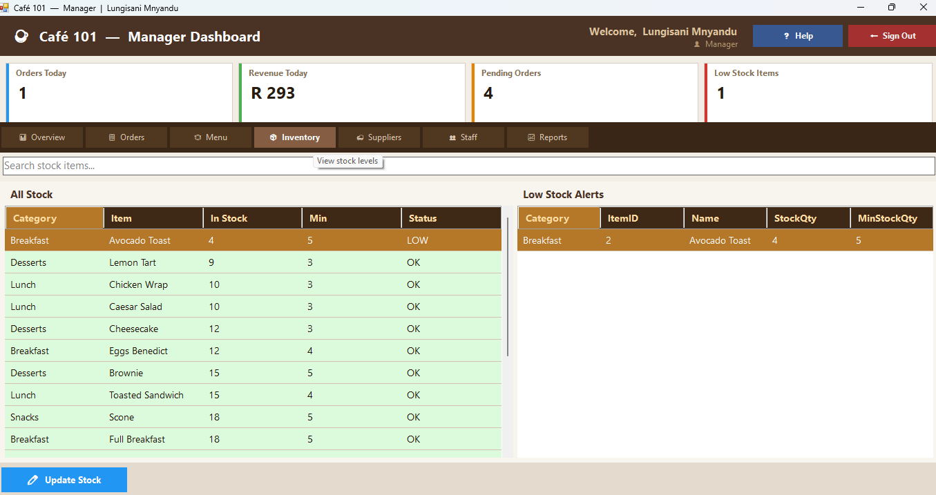
Figure 3: Inventory Management

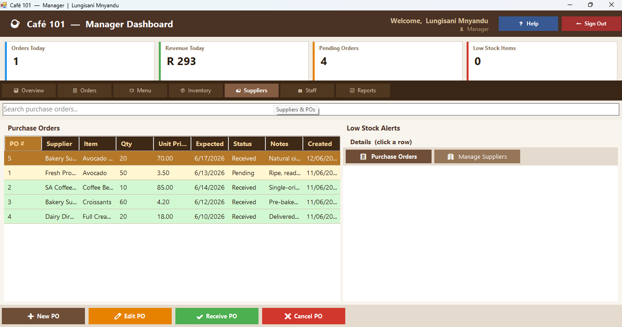
Figure 4:Supplier Management

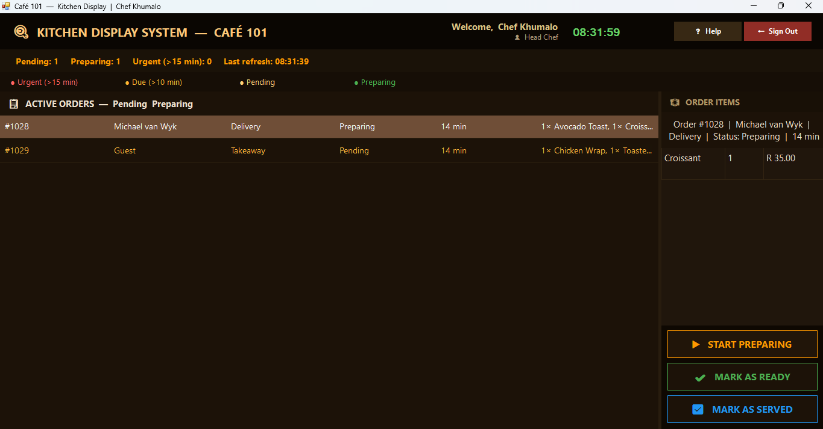
Figure 5: Kitchen Display

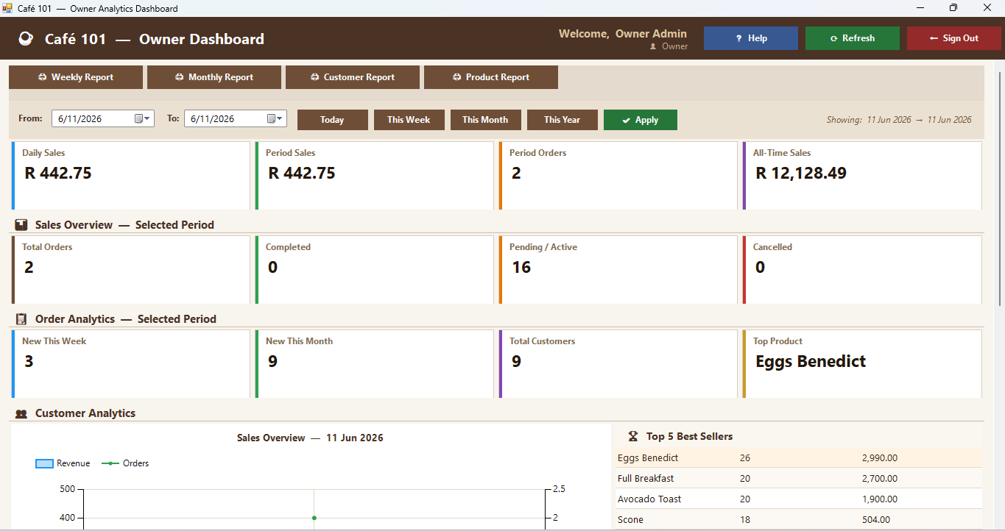
Figure 6: Manger Dashboard

11. Security Design
Security was an important consideration throughout the development of Café 101. The following security measures were built into the system to protect both the business data and the users.

Security Measure | How It Works
Password Hashing | When a user sets a password, the system converts it into a hashed value using SHA-256 encryption before saving it to the database. This means that even if someone accesses the database directly, they cannot read any user's password.
Role-Based Access Control (RBAC) | When a user logs in, the system checks their role and opens only the screen for that role. There is no way for a cashier to accidentally access the manager's screen, or for any user to navigate to a part of the system they are not allowed to use.
SQL Injection Prevention | All database queries in the system use parameterized statements, which means user input is never directly inserted into a SQL query. This protects the database from SQL injection attacks, which are one of the most common types of security vulnerabilities in software systems.
Login Lockout | The system keeps count of how many times a user enters the wrong password in a row. After three failed attempts, the account is locked and a message is shown to the user. This prevents someone from trying to guess a password repeatedly.
Safe Error Messages | When something goes wrong in the system, the error message shown to the user is a simple, friendly message. The system never shows technical details like stack traces, which could give an attacker information about how the system works.

12. System Testing
All test cases were carried out manually by the development team using the live system connected to the SQL Server database. Each test was run at least once and the result was recorded. All 22 tests passed successfully.

TC# | What Was Tested | Expected Result | Result
TC-01 | Login with correct username and password | User is taken to the correct role dashboard | PASS
TC-02 | Login with wrong password three times in a row | Account is locked and a lockout message is shown | PASS
TC-03 | Add a new customer | Customers are saved and appears in the customer list | PASS
TC-04 | Edit an existing customer's details | The record is updated and the list is refreshed | PASS
TC-05 | Delete a customer who has no active orders | The customer is removed from the database | PASS
TC-06 | Place a Dine-In order | The order is saved, the receipt is printed, and the kitchen queue is updated | PASS
TC-07 | Try to place a Delivery order without entering an address | The system blocks the order and shows an error message | PASS
TC-08 | Place a Delivery order with an address filled in | The order is saved together with the delivery address | PASS
TC-09 | Cancel an order that has been started but not placed | The cart is cleared and no record is saved in the database | PASS
TC-10 | Head Chef marks an order as Preparing | The status is updated and the row changes to blue | PASS
TC-11 | Head Chef marks an order as Ready | The status is updated and the row changes to green | PASS
TC-12 | Head Chef marks an order as Served | The order has been removed from the kitchen queue | PASS
TC-13 | Manager adds a new menu/inventory item | The item is saved and appears in the menu list | PASS
TC-14 | Manager sets a stock quantity below the minimum | The row is highlighted in red, and a low-stock alert is shown | PASS
TC-15 | Manager adds a new supplier | The supplier is saved and is available in the purchase order workflow | PASS
TC-16 | Manager to create a purchase order | The purchase order is saved with a status of Pending | PASS
TC-17 | Manager cancels a purchase order | The purchase order status is updated to Cancelled | PASS
TC-18 | Manager registers a new staff member | The employee record is created, and the staff member can now log in | PASS
TC-19 | Owner filters KPIs by a specific date range | The KPI tiles and chart update to show data for the selected period | PASS
TC-20 | Owner views the top 5 selling items | The grid is filled with the five best-selling products in the selected period | PASS
TC-21 | Owner prints the weekly sales report | The report is sent to the printer with the correct data | PASS
TC-22 | Owner prints the customer analytics report | The customer report is printed correctly | PASS

13. Implemented User Stories / Functionality Listing
All 17 user stories that were planned at the start of the project have been fully built and tested. The table below gives a description of each feature that was completed, including which role it uses and its status.

# | Feature | Description | Role | Status
1 | Role-Based Login & Lockout | Users log in using their email and password. The system checks the password, identifies the user's role, and opens the correct dashboard. After three wrong attempts, the account is locked. | All | ✅ Complete
2 | Customer Management | The cashier can add new customers, edit their details, search for them by name, and delete records. Deletion is blocked if the customer has active orders. | Cashier | ✅ Complete
3 | Point-of-Sale — Order Placement | The cashier can browse the menu by category, add items to the cart, see the running total with tax and discounts, choose the order type and payment method, and place the order. | Cashier | ✅ Complete
4 | Receipt Generation | When an order is placed, the system automatically generates a receipt and sends it to the printer. The receipt shows all items, quantities, line totals, tax, and the grand total. | Cashier | ✅ Complete
5 | Delivery Address Capture | When the cashier selects Delivery as the order type, address fields appear. The order cannot be submitted until both the city and suburbs are filled in. | Cashier | ✅ Complete
6 | Kitchen Display — Order Queue | The Head Chef can see a live, colour-coded list of all active orders. Clicking on an order shows the full list of items in the right panel. | Head Chef | ✅ Complete
7 | Kitchen Display — Status Updates | The Head Chef can move an order through three stages: Preparing, Ready, and Served. The colour of the row changes automatically to show the current stage. | Head Chef | ✅ Complete
8 | Inventory / Menu Management | The manager can add, edit, and delete menu items. Each item has a minimum stock level and if the stock drops below that level, the item is highlighted and a warning is shown. | Manager | ✅ Complete
9 | Supplier Management | The manager can keep the register of all suppliers with their company name, contact details, and address. A supplier cannot be deleted if they are linked to an open purchase order. | Manager | ✅ Complete
10 | Purchase Order Management | The manager can create a purchase order for a supplier, listing the items, quantities, and prices. The order's status (Pending, Received, or Cancelled) can be updated as needed. | Manager | ✅ Complete
11 | Employee / Staff Management | The manager can register new staff members (which also creates a system login for them), update their details, and deactivate staff who have left the café. | Manager | ✅ Complete
12 | Order Management & Status Updates | The manager can view all orders, filter them by status, and manually update an order's status if needed. Colour coding makes it easy to see where each order is in the process. | Manager | ✅ Complete
13 | Sales & Operational Reports | The manager can print Daily, Weekly, and Monthly sales reports. The owner can also print Customer and Product Performance reports. | Manager / Owner | ✅ Complete
14 | Owner KPI Dashboard — Date Range Filter | The owner can choose a From and to date, and all the KPI tiles (total revenue, order count, average order value, and payment method breakdown) update to show figures for that period. | Owner | ✅ Complete
15 | Sales Chart | The owner's dashboard includes a chart that shows daily revenue and order count as a line and area graph for the selected date range. | Owner | ✅ Complete
16 | Top & Least Selling Products | The owner can see a grid of the top 5 best-selling items and a grid of the 5 least-selling items for the selected period. This helps the owner make decisions about the menu. | Owner | ✅ Complete
17 | Customer Analytics | The owner can see how many new customers versus returning customers placed orders in the selected period, as well as how frequently customers are ordering. | Owner | ✅ Complete

- All use case stories are successfully completed

14. System Benefits
The Café 101 system brings real benefits to everyone involved in running the café. The table below summarises what each group gains from using the system.

Who Benefits | How They Benefit
Cashier & Head Chef | Orders are no longer written on paper, which means fewer mistakes. The kitchen always knows exactly which orders to prepare and in what order. Receipts are printed automatically, giving customers a proper record of their purchase.
Manager | The manager can see everything happening in the business from one screen. All purchases from suppliers are tracked through purchase orders, creating a clear record. Every action in the system is linked to a specific user, which makes it easy to hold staff accountable.
Owner | The owner can check the business's performance at any time without waiting for end-of-month reports. Being able to compare different time periods makes it easier to spot trends and plan. All reports can be printed and shared with stakeholders.
Customers | Orders are processed faster and more accurately. Delivery orders always have the correct address recorded. Better stock management means the café is less likely to run out of popular items.

15. Future Enhancements
Although all the planned features have been built and are working, there are several improvements that could be added in the future to make the system even better. These were not included in this version because they were outside the scope of the project.

Enhancement | Description
Email-Confirmed Password Reset | Now, if a user forgets their password, a manager must manually reset it. A future version of the system should allow users to reset their own passwords through a secure process where a one-time link is sent to their registered email address. The user would click the link, which would expire after a set time (for example, 15 minutes), and only then be allowed to create a new password. This would make the system more secure because it confirms that the person requesting the reset owns that email address, reducing the risk of someone else changing another user's password without permission.
Mobile Application | A mobile app for iOS and Android would allow customers to place orders from their phones and let managers check business reports from anywhere. This would make the system more flexible and accessible.
Online Ordering Portal | A website where customers could place orders online and have them come through directly to the system would reduce the workload on cashiers and allow the café to accept more orders at once.
GPS Delivery Tracking | Adding real-time GPS tracking would allow customers and managers to see exactly where a delivery driver is and get an estimated arrival time. This would improve customer experience for delivery orders.
Cloud Database Migration | Moving the database from the current on-site server to a cloud service like Microsoft Azure SQL would make it possible to run the system across multiple café branches while keeping all the data in one place.
Automated SMS / Email Notifications | The system could automatically send customers a message when their order is confirmed, when it is being prepared, and when it is ready for collection or out for delivery. This would keep customers informed without staff needing to make phone calls.

16. Conclusion
The Café 101 Order and Delivery Management System was successfully designed, built, tested, and documented by Code Crafters as the final project for the ISTN3AS module at the University of KwaZulu-Natal.
The team set out to build a system that would solve the real problems faced by a small café business — manual order mistakes, poor stock visibility, and no way to quickly see how the business is performing. All 17 planned user stories were fully completed and tested.
The system successfully provides four different role-based dashboards, a complete ordering and delivery workflow, stock and supplier management tools, and a powerful analytics and reporting dashboard for the owner. The Code Crafters team is proud of the final product and believes it demonstrates a solid understanding of systems analysis and design principles.

